Force Calculations Team 9

Sketch of our beam is at the end of the two pages.

# To find max Bending moment using Bending Stress calculation

Bending stress = $\frac{Bending moment*distance from centroid to applied force}{first moment of inertia}$

σ= $\frac{M*x}{I}$

$M$ = $\frac{σI}{x}$

= $\frac{44,000,000\left(\frac{N}{m^{2}}\right)*(\frac{1}{12}\left(0.06\right){\left(0.1\right)}^{3})(m^{4})}{0.05(m)}$

$M$ =4400Nm

# To find max force using previously calculated bending moment

Max Force= $\frac{2*Max bending Moment}{length of beam}$

Fmax =

=

Fmax = 7.213 kN

σ=44MPa was given to us in lab.

All other measurements where either calculated or taken directly from beam.

# Calculation of mass to weight ratio

|  |  |  |  |  |  |
| --- | --- | --- | --- | --- | --- |
| Part No. | Amount | Width | Height | Thickness | Volume Total  (Columns 2-5 multiplied) |
| 1 | 2 | 1.22m | 0.094m | 0.003m | 0.00068808m3 |
| 2 | 2 | 1.22m | 0.06m | 0.003m | 0.0004392m3 |
| 3 | 11 | 0.054m | 0.094m | 0.003m | 0.00016751m3 |
| 4 | 10 | 0.094m | 0.12m | 0.003m | 0.0003384m3 |

Therefore Total Volume of all pieces by density = mass of beam

Total of all volumes = 1.633x10-3 m3

Density given in class = 800kg/m3

Mass = 1.307kg

Force : Mass

7.213kN : 1.307kg

5.519kN : 1.000kg

# Design of beam

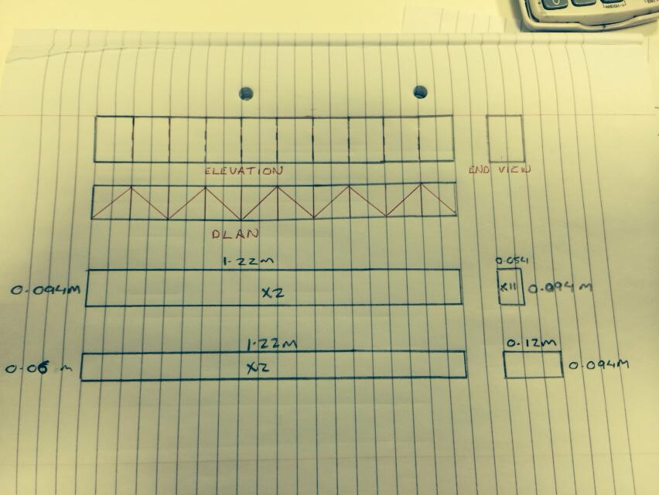

# Actual Force vs mass readings and comparison

|  |  |  |  |
| --- | --- | --- | --- |
|  | Calculated | Actual | % Error |
| Force (N) | 7213 | 2100 | 243% |
| Mass (kg) | 1.307 | 1.4 | 6.6% |
| Force/mass ratio (N/kg) | 5519 | 1500 | 268% |

# Reasons for Errors

1. Craftsmanship errors in gluing of beam and cutting of pieces.
2. In calculations beam is assumed to be made fully of MDF, ie no glue.
3. For calculations we took the three positions where we assumed the forces would be placed and calculated our bending moments about them, this resulted in the beam assuming a solid cuboid shape, and not the support type structure it was.
4. Mass of beam is almost perfectly correct we have not included mass of glue in beam in theoretical calculations.
5. When talking to other groups we noticed that an error rate of c. 250%, even though it seems quite large, was actually quite small in comparison to most groups predicted vs actual Force and Failure load / mass ratio.
6. During construction we realized that we were c. 25mm short on either side of the beam so we added extra MDF pieces in to fill up the space. (see photos)

# How beam came to destruction

The beam handled the load being exerted on it very well until it reached 2.1kN, were the MDF at each side of the beam and the MDF at the bottom of the beam all snapped in unison, just to the back of the middle support structure. Our gluing, which was the failure point of most beams, held tight. Our beam essentially was tested to destruction and not failure due to these factors. We used the strength of the MDF width to our advantage in this case as it had the best strength to bending moment ratio for the task at hand.